SPECIMENUL CERTIFICATULUI COMPETENȚEI LINGVISTICE

CIVIL AVIATION AUTHORITY OF THE REPUBLIC OF MOLDOVA  ENGLISH LANGUAGE PROFICIENCY FOR AERONAUTICAL COMMUNICATION |  | 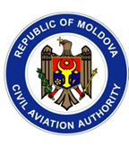
 | Certificate of English Language Proficiency
This is to certify that:

Name, Surname

has achieved ICAO Level 4
Expiration Date: dd.mm.yyyy Director of Civil Aviation Authority: / Name, Surname/
(Signature/ Name)

(Stamp of CAA RM)

